Exercise 2: LLM Leaderboard

Favorite LLM
GPT-5.6 Luna
Artificial Analysis Intelligence Index: 52
Two new models tried: Z.AI GLM-4.7 and Qwen3.7-Plus.

Prompt 1: Explain machine learning to a beginner using a simple real-world example.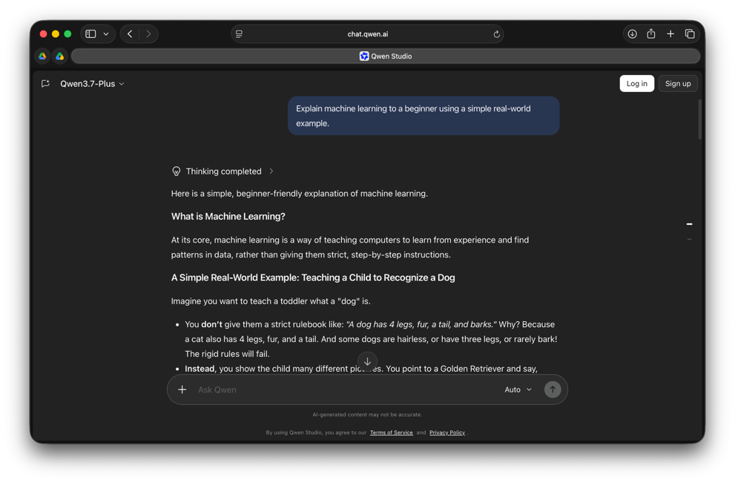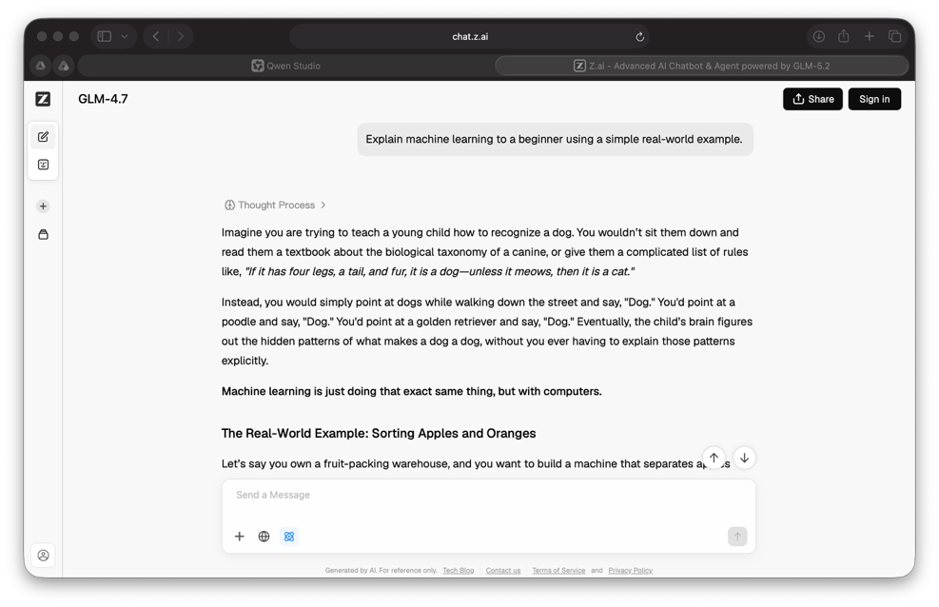
Prompt 2: Write a Python program that checks whether a number is prime. Explain the code briefly.

